User

User over view

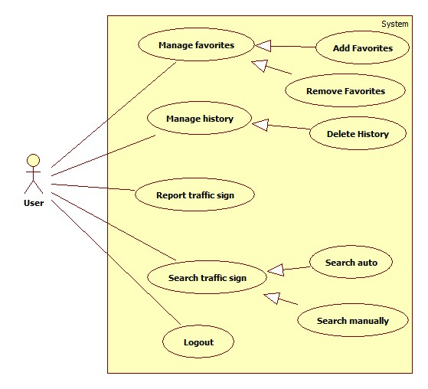

Logout

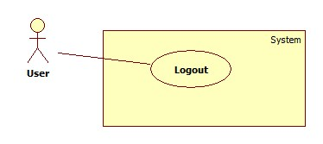

|  |  |  |  |
| --- | --- | --- | --- |
| **USE CASE – UU001** | | | |
| **Use Case No.** | UU001 | **Use Case Version** | 1.0 |
| **Use Case Name** |  | | |
| **Author** |  | | |
| **Date** | 15/01/2014 | **Priority** | Normal |
| **Actor:** User  **Summary:**  User use this case to logout  **Goal:**  Allow user to logout  **Triggers:**  User want to logout  User click on “Thoát” button  **Preconditions:**   * User must logged in the system with the role is user.   **Post Conditions:**  **Success:** User logout and redirect to home  **Fail:**  **Main Success Scenario:**   |  |  |  | | --- | --- | --- | | Step | Actor Action | System Response | | 1 | User click on “Thoát” button | System delete user session and redirect to home page |   **Alternative Scenario:** N/A | | | |
| **Relationships:** N/A  **Business Rules:** N/A | | | |

Search traffic sign

Reference to Guest search traffic sign usecase

Report traffic sign

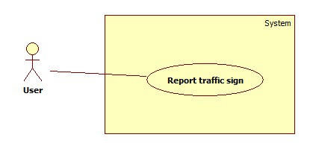

|  |  |  |  |
| --- | --- | --- | --- |
| **USE CASE – UU002** | | | |
| **Use Case No.** | UU002 | **Use Case Version** | 1.0 |
| **Use Case Name** | Send Report | | |
| **Author** | Ho Dac Nghia | | |
| **Date** | 15/01/2014 | **Priority** | Normal |
| **Actor:** User  **Summary:**  User use this case to report traffic sign.  **Goal:**  Allow user to report traffic sign  **Triggers:**  User want to report wrong traffic sign(wrong information or wrong recognize traffic sign)  When user view search result and think that result is wrong then user can click on report item.  **Preconditions:**   * User must logged in the system with the role is user.   **Post Conditions:**  **Success:** The report of a traffic sign will be save on server  **Fail:** No report send.  **Main Success Scenario:**   |  |  |  | | --- | --- | --- | | Step | Actor Action | System Response | | 1 | While view search result, user click on the report item | System redirect to report page:   * Textbox: “Nội dung phản hồi” * Button: “Hủy” * Button: “Gửi” | | 2 | User input report content and click on “Gửi” button  [Alternative 1] | System send report to server and show message “Cám ơn bạn đã gửi phản hồi” and go back to result page |   **Alternative Scenario:**   |  |  |  | | --- | --- | --- | | No | Actor Action | System Response | | 1 | User click on “Hủy” button | System back to result page | | | | |
| **Relationships:** N/A  **Business Rules:** N/A | | | |

Manage history

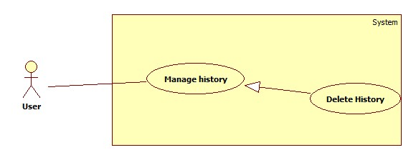

|  |  |  |  |
| --- | --- | --- | --- |
| **USE CASE – UU003** | | | |
| **Use Case No.** | UU003 | **Use Case Version** | 1.0 |
| **Use Case Name** | Delete history | | |
| **Author** | Mai Van Tan | | |
| **Date** | 15/01/2014 | **Priority** | Normal |
| **Actor:** User  **Summary:**   * User uses this case to delete search history.   **Goal:**   * Allow user delete their search history.   **Triggers:**   * User want to delete history of search result * User clicks on the delete item of the history item.   **Preconditions:**   * User must login.   **Post Conditions:**   * **Success**: The history is deleted from history list. * **Fail:** Show the error to user.   **Main Success Scenario:**   |  |  |  | | --- | --- | --- | | Step | Actor Action | System Response | | 1 | User clicks on view history item. | System will show the list search history to screen. | | 2 | User clicks on delete item of history item. | System show message “Bạn có chắc chắn xóa?” | | 3 | User click “OK”  [Alternative 1] | System delete history and show the message “Xóa thành công” then refresh the list history.  [Exception 1] |   **Alternative Scenario:**   |  |  |  | | --- | --- | --- | | No | Actor Action | System Response | | 1 | User click “Cancel” | Close message box |   **Exceptions:**   |  |  |  | | --- | --- | --- | | No | Actor Action | System Response | | 1 | Cannot delete history. | Show message: “Xóa không thành công”. |   **Relationships: N/A**  **Business Rules: N/A** | | | |
|  | | | |

Add favorites

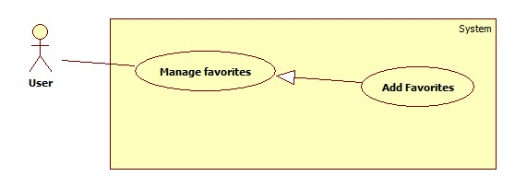

|  |  |  |  |
| --- | --- | --- | --- |
| **USE CASE – UU004** | | | |
| **Use Case No.** | UU004 | **Use Case Version** | 1.0 |
| **Use Case Name** | Add to favorite | | |
| **Author** | Bui Viet Phong | | |
| **Date** | 15/01/2014 | **Priority** | Normal |
| **Actor:** User  **Summary:**  This user case allow user to add a traffic sign into favorite list.  **Goal:**  Add a traffic sign into favorite list.  **Triggers:**   * In our system, each user has a favorite list to bookmark traffic signs for viewing later again. * To add a traffic sign into favorite list, user must: * View traffic sign details by auto search or manually search. * On the traffic sign details screen, click on favorite item.   **Preconditions:**   * Guest must log in the system. * The traffic sign is not added into favorite list before.   **Post Conditions:**   * **Success:** The popup inform that the traffic sign has been added to favorite list * **Fail:** No traffic sign has been added to favorite list.   **Main Success Scenario:**   |  |  |  | | --- | --- | --- | | Step | Actor Action | System Response | | 1 | - Click ‘Tra cứu biển báo’  - Choose one item in category.  [Alternative 1] | Show the list of traffic signs in the category which was chosen by user before. | | 2 | Choose one traffic sign in the list. | Show the Traffic details screen, contains detail of traffic sign, include:   * Traffic sign Image * Traffic sign content * Penalize fee. | | 3 | Click on favorite item at the top-right corner of the screen. | Add the traffic sign to favorite list and show the notice with message:  “Biển báo đã được thêm vào danh sách yêu thích” |   **Alternative Scenario:**   |  |  |  | | --- | --- | --- | | No | Actor Action | System Response | | 1 | [Alternative 1]  - Click “Nhận diện biển báo”.  - Take a photo contains traffic sign(s). | Submit photo to web service and receive and show the result include :  The screen with two part:   * The image was taken by user. * The list of traffic signs.   [Exception 1] | | 2 | Choose one traffic sign in the list. | Show the Traffic details screen, contains detail of traffic sign, include:   * Traffic sign Image * Traffic sign content * Penalize fee. | | 3 | Click on favorite item at the top-right corner of the screen. | Add the traffic sign to favorite list and show the notice with message:  “Biển báo đã được thêm vào danh sách yêu thích” |   **Exceptions:**   |  |  |  | | --- | --- | --- | | No | Actor Action | System Response | | 1 | No result found | Show message “Không nhận diện được biển báo” |   **Relationships:** Manage favorite  **Business Rules:** N/A | | | |

Remove favorites (******** mobile?webapp?)

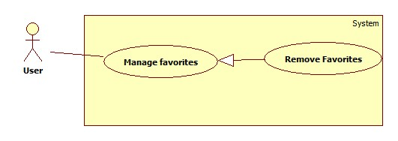

|  |  |  |  |
| --- | --- | --- | --- |
| **USE CASE – UU005** | | | |
| **Use Case No.** | UU005 | **Use Case Version** | 1.0 |
| **Use Case Name** | Remove from favorite list | | |
| **Author** | Bui Viet Phong | | |
| **Date** | 15/01/2014 | **Priority** | Normal |
| **Actor:** User  **Summary:**  This user case allow user to remove a traffic sign from favorite list.  **Goal:**  Remove a traffic sign from favorite list**.**  **Triggers:**   * In our system, each user has a favorite list to bookmark traffic signs for viewing later again. * To remove a traffic sign from favorite list, user must: * Select ‘Danh sách yêu thích’ to view favorite list. * Select and hold on the traffic sign for 1 second. * Select ‘Xóa’.   **Preconditions:**   * Guest must logged in the system.   **Post Conditions:**   * **Success:** The traffic sign has been remove from favorite list. * **Fail:** No traffic signs has been remove from favorite list.   **Main Success Scenario:**   |  |  |  | | --- | --- | --- | | Step | Actor Action | System Response | | 1 | - Click ‘Danh sách yêu thích’  [Alternative 1] | Show the list of traffic signs in the favorite list. | | 2 | Select and hold on one traffic sign in the list for 1 second. | Show the menu, contains below items:   * Chuyển lên trên * Chuyển xuống dưới * Xóa | | 3 | Select ‘Xóa’ | Remove the traffic sign from favorite list. |   **Alternative Scenario:**   |  |  |  | | --- | --- | --- | | No | Actor Action | System Response | | 1 | [Alternative 1]  - View detail of traffic sign in use case ….  - Select the “Yellow star” on the top-right screen | Remove the traffic sign from favorite list. |   **Exceptions:** N/A  **Relationships:** Manage favorite  **Business Rules:** N/A | | | |